NIRMAYEE S. KADAM PRN-25070521134 SEC-C1
EX 6.1.2-FACTORIAL OF NUMBER
ALGORITHM:
- Start: Take the input number n.
- Initialize: Create a variable and set its initial value to 1.
- Loop: For every number i starting from 1 up to and including n:
- Multiply the current value of factorial by i.
- Update factorial with this new product (factorial = factorial * i).
- Result: After the loop finishes, the value stored in factorial is your final answer.
- Output: Print the result.

FLOWCHART:
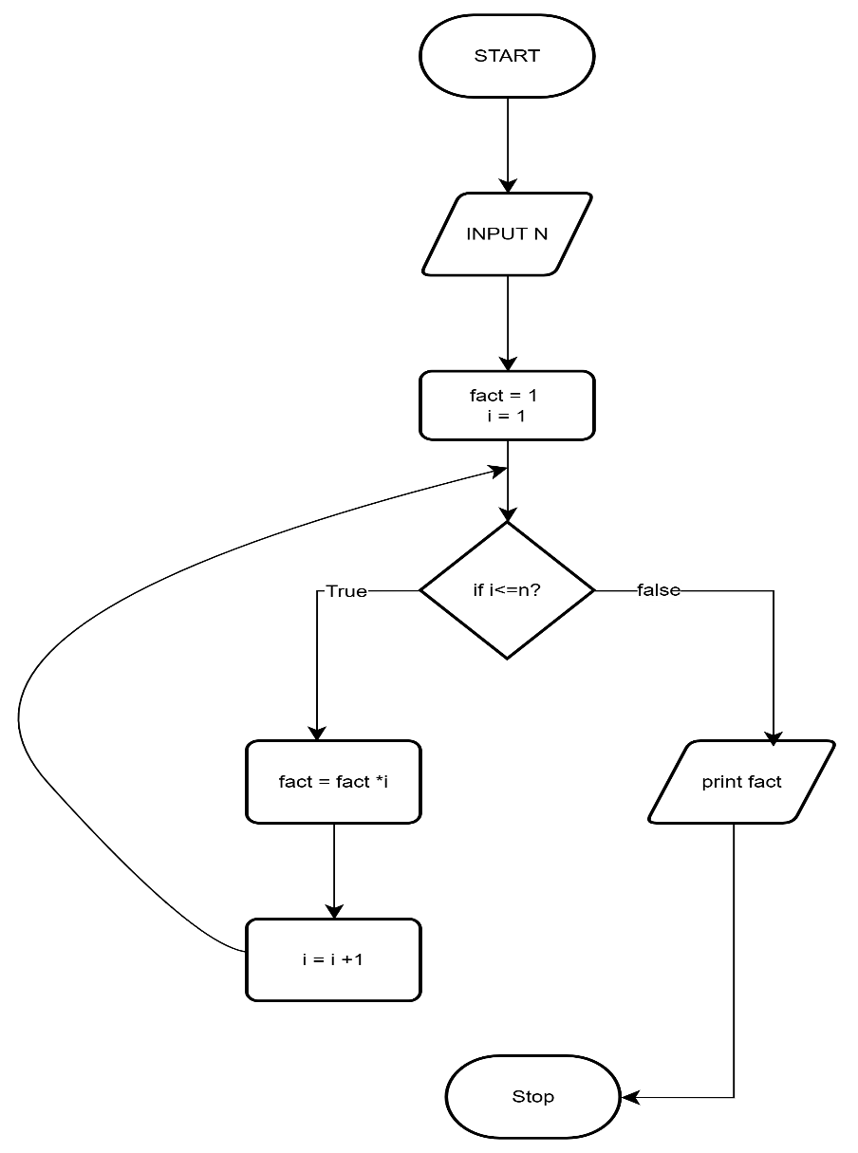
NIRMAYEE S. KADAM PRN-25070521134 SEC-C1

CODE:
